15.77: a) Solving Eq. (15.35) for the tension F,

b) The tension must increase by a factor of 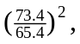and the percent increase is 